Red Ribbon Week Dress-Up Days
2021
Tuesday was Crazy Hair and Sock Day. “From our Head to Our Toes, We’re Drug-Free!”
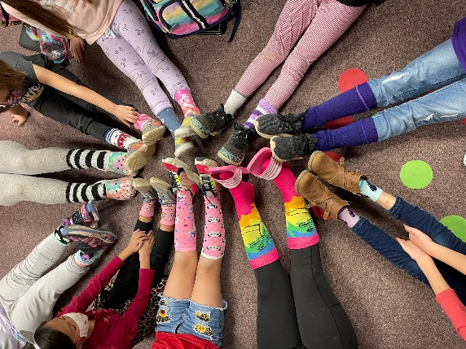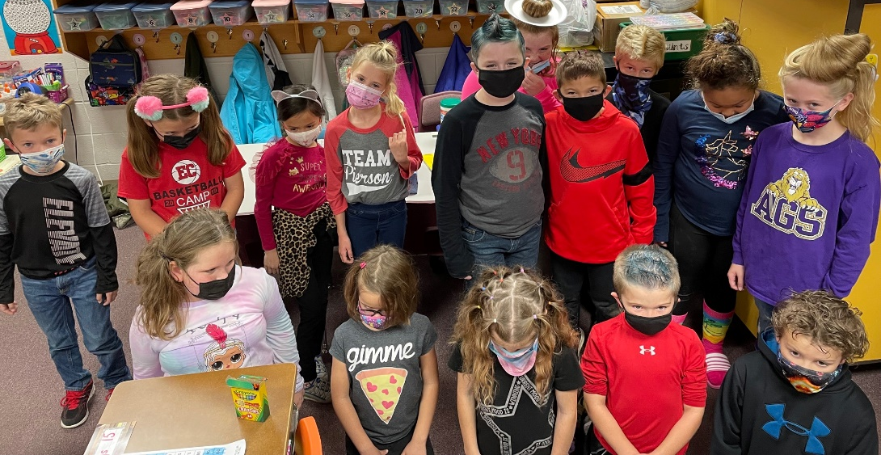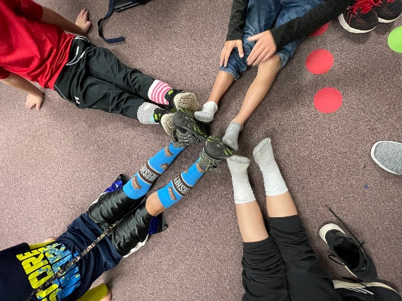

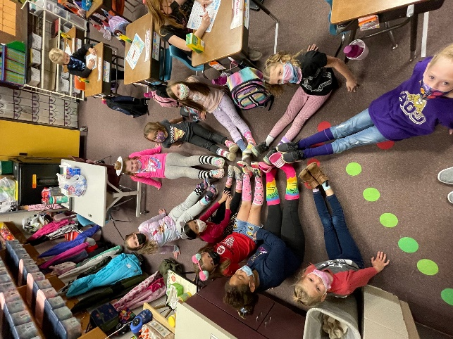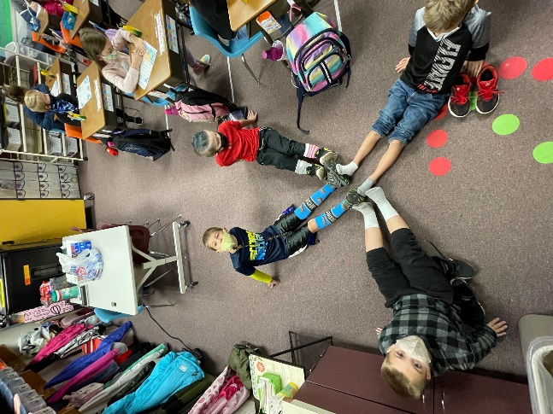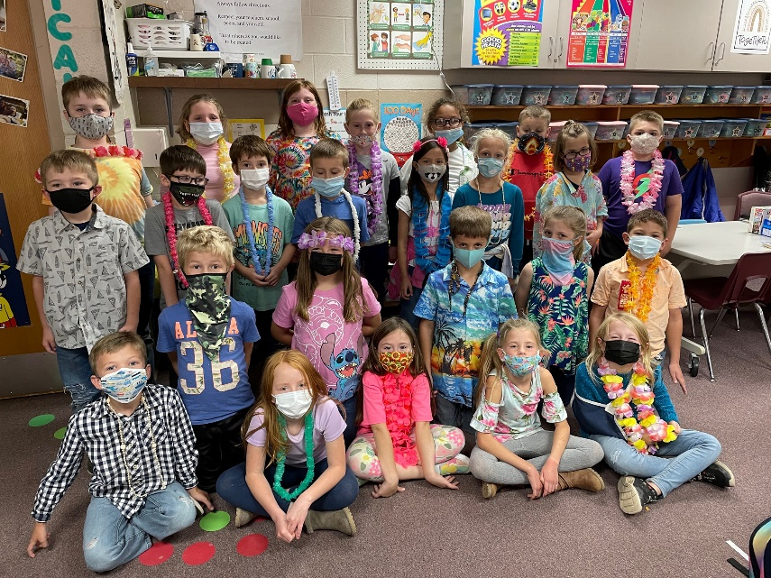
It was really fun to dress up each day. On Wednesday, it was Hawaiian Day, “Lei Off Drugs.”
Thursday was Decade’s Day. “Don’t Be a Hippie, Stay Drug-Free”.
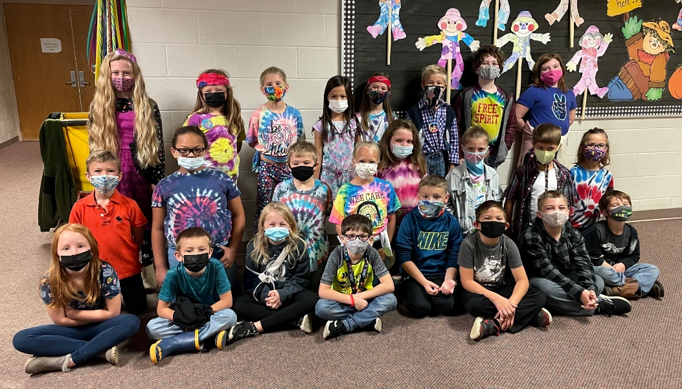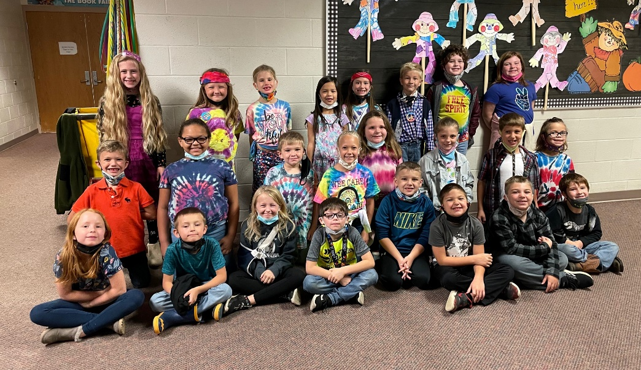
Friday was Costume Day; “Say Boo to Drugs!”
